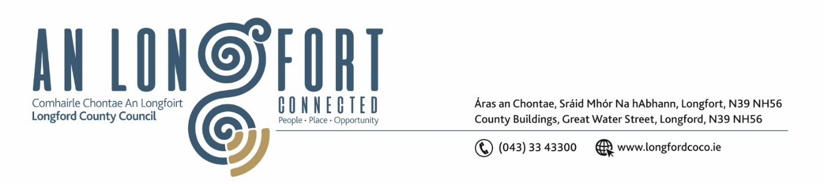

**LONGFORD MUNICIPAL DISTRICT**

**Minutes of Meeting of Longford Municipal District**

**held in the Council Chamber Aras an Chontae and via MS Teams**

**on Tuesday, 15 October 2024 at 11am**

**CATHAOIRLEACH**: Councillor Seamus Butler

**MEMBERS PRESENT**: Councillors Peggy Nolan, Uruemu Adejinmi, Martin Monaghan, Kevin Hussey, Niall Gannon

**IN ATTENDANCE**: Mr. John Brannigan, Director of Services

Mr. David McNiff, A/Senior Executive Engineer

Ms. Lorraine McKee A/Senior Executive Officer

Ms. Louise Kiernan, Senior Planner

Ms. Lorraine O’Connor, Town Regeneration Officer

**MEETINGS**

**ADMINISTRATOR:**  Ms. Lorraine McKee

**APOLOGIES:** Councillor Gerry Hagan

1. **ADOPTION OF MINUTES – circulated**
2. On the proposal of Councillor Uruemu Adejinmi seconded by Councillor Peggy Nolan it was unanimously agreed to adopt Minutes of Meeting of Longford Municipal District held on 23 July 2024 as circulated.
3. On the proposal of Councillor Martin Monaghan seconded by Councillor Uruemu Adejinmi it was unanimously agreed to adopt Minutes of Committee Meeting of Longford Municipal District held on 23 July 2024 as circulated.
4. On the proposal of Councillor Kevin Hussey seconded by Councillor Peggy Nolan it was unanimously agreed to adopt Minutes of Committee Meeting of Longford Municipal District held on 6 August 2024 as circulated.
5. On the proposal of Councillor Uruemu Adejinmi seconded by Councillor Martin Monaghan it was unanimously agreed to adopt Minutes of Committee Meeting of Longford Municipal District held on 13 August 2024 as circulated.
6. On the proposal of Councillor Peggy Nolan seconded by Councillor Uruemu Adejinmi it was unanimously agreed to adopt Minutes of Committee Meeting of Longford Municipal District held on 28 August 2024 as circulated.
7. On the proposal of Councillor Martin Monaghan seconded by Councillor Peggy Nolan it was unanimously agreed to adopt Minutes of Meeting of Longford Municipal District held on 24 September 2024 as circulated.
8. **MATTERS ARISING FROM MINUTES**

None

1. **DECLARATION OF INTEREST BY MEMBERS**

None

1. **CONSIDERATION OF DRAFT STANDING ORDERS FOR LONGFORD MD**

**Noted**

1. **MANAGEMENT REPORT – as circulated.**

David McNiff updated the members with the Management Report, and it was noted.

1. **CONSIDERATION OF PART VIII – NO. 119 LAMAGH, NEWTOWNFORBES, CO. LONGFORD**

On the proposal of Councillor Martin Monaghan, seconded by Councillor Peggy Nolan the Part VIII No 119 Lamagh, Newtownforbes, Co. Longford as presented was approved.

1. **LONGFORD TOWN AREA PLAN**

Louise Kiernan gave the Members a detailed update and progress on the Longford Town Area Plan

1. **2025-2027 MULTI ANNUAL IMPROVEMENT PROGRAMME**

Noted – David McNiff will make a presentation for approval at the next meeting of Longford Municipal District

1. **THRIVE PROJECT**

Lorraine O’Connor gave the members a detailed update and progress report on the THRIVE project.

1. **NOTICE OF MOTIONS**

**The following Notice of Motion was proposed by Councillor Uruemu Adejinmi and seconded by Councillor Martin Monaghan**

I am calling for review of the Local Improvement Scheme (LIS) to ensure that during assessment of LIS applications received, each Municipal District is given an annual allocation under the scheme.

**Response:**

I have examined the parameters of this scheme especially Section 4 Selection and Prioritisation of Projects which states: “In no circumstances should allocations be divided among elected representatives or between electoral areas on the basis of the number of elected representatives in those areas.”

While I understand the call for this Notice of Motion, the scheme does not permit an allocation per Municipal District.

**The following Notice of Motion was proposed by Councillor Martin Monaghan and seconded by Councillor Uruemu Adejinmi**

I call on Longford County Council to tidy the footpath and cut back the hedging between the Red Cow roundabout and the Leo Casey roundabout, this part of the bypass is in urgent need of attention.

**Response:**

Hedgerow maintenance was carried on the National and Regional roads during July/August and the entire bypass was cut during this contract. Autumn is a difficult period to maintain this footpath, but we are trialling a new road sweeper which we hope will be able to improve the maintenance of the path in this area.

**The following Notice of Motion was proposed by Councillor Martin Monaghan and seconded by Councillor Uruemu Adejinmi**

I call on Longford County Council to repair the road surface at the roundabout at McDonalds as it is in very poor condition.

**Response:**

We have no immediate plan to carryout works on this section of the road until the works on the Battery Road have been completed. We will look to include this section of the road network in the 2025 Roads Programme.

1. **DATE AND TIME OF NEXT MEETING**

The next meeting of Longford Municipal District will take place on Tuesday 26 November at 11am.

This concluded the business of the meeting.

**Signed: ____________________**

**Lorraine McKee**

**A/Meetings Administrator.**

**Confirmed and adopted at Longford Municipal District Meeting held on the 26 November 2024.**

**Signed: _______________**

**Cathaoirleach**